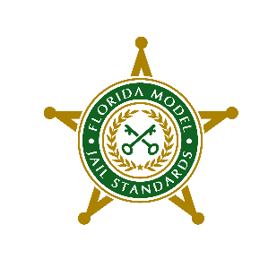
FLORIDA MODEL JAIL STANDARDS

AWARDS and NOMINATION

GUIDELINES

Each year we honor members of the FMJS community by presenting awards to deserving individuals who ensure and maintain the integrity of the FMJS process. This is a great opportunity to recognize the exceptional work FMJS professionals do around the state.

There are many deserving individuals in the FMJS community and the only way they can be recognized is for you to take the time to complete the nomination form. For a few minutes of your time, you have the ability to recognize those individuals who go above and beyond to make the FMJS program what it is today.

Presentation of the awards will take place at the FLA-PAC Conference in St. Augustine, Florida, February 19-22, 2024 during the FMJS Working Group Meeting.

The Awards of the Florida Model Jail Standards are as follows:

- FMJS Medical Inspector of the Year

  - Eligibility Criteria
    - Currently holds an active FMJS certificate
    - Healthcare license or EMT certificates remain current
    - Currently or previously employed in a correctional setting

  - Selection Criteria
    - Actively participates in yearly inspections, actively participates in inspections as Team Leader, and provides agency assistance. The inspector nomination form must carry the endorsement of the administrator of the agency in which the inspector is currently employed. Inspector demonstrates exceptional knowledge and assistance to the agency being inspected.

- FMJS Inspector or the Year

  - Eligibility Criteria
    - Currently holds an active FMJS certificate
    - Currently or previously employed in a correctional setting

  - Selection Criteria
    - Actively participates in yearly inspections, actively participates in inspections as Team Leader, and provides agency assistance. The inspector nomination form must carry the endorsement of the administrator of the agency in which the inspector is currently employed. Demonstrates exceptional knowledge and assistance to the agency being inspected.

- FMJS Team Leader of the Year

  - Eligibility Criteria
    - Leadership
    - Currently holds an active FMJS certificate
    - Coaching and mentoring FMJS Inspectors
    - Demonstrated commitment to the FMJS process
    - Currently or previously employed in a correctional setting

  - Selection Criteria
    - Actively participates in yearly inspections, actively participates in inspections as Team Leader, and provides agency assistance. The inspector nomination form must carry the endorsement of the administrator of the agency in which the inspector is currently employed. Team Leader demonstrates exceptional knowledge and assistance to the agency being inspected. Coordinates the inspection with the assigned team members and demonstrates exceptional leadership skills.

- FMJS Chairman’s Award

  - Eligibility Criteria
    - Currently or previously employed in a correctional setting
    - Contributions have made significant improvement to the FMJS process

  - Selection Criteria
    - Actively participates in the process, for outstanding achievement, innovation, creativity, and smart work that measurably increases the FMJS program efficiency or furthers the FMJS goals. The nomination must carry the endorsement of the sheriff or county administrator of the agency in which the individual is employed.

SUBMIT YOUR NOMINATION!
Please complete the nomination form found at www.flsheriffs.org. All nominations must be postmarked or emailed by January 1, 2024
INSTRUCTIONS: Complete the Nomination Form. Include written justification for the nomination. Attach additional pages as necessary, but give the Full Committee ample justification to support your nomination. Nominations are strengthened by a thorough discussion of the nominee’s accomplishments.
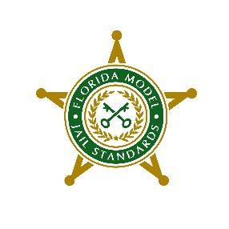
FLORIDA MODEL JAIL STANDARDS

NOMINATION FORM

Date: Click or tap to enter a date.

Name of Nominee: Click or tap here to enter text.

Agency Employed by: Click or tap here to enter text.

Award Nominated for: Choose an item.

Reason for Nomination:
Please attach a separate sheet if additional space is needed.

Person Submitting Nomination:
Name:

Facility/Agency Name:
Facility/Agency Address:
Facility City: | State: | Zip:
Phone:

Endorsement by Sheriff or County Administrator:
Signature:

FMJS Full Committee Action:
Approved ☐ | Disapproved ☐

Please mail or e-mail the completed nomination to:

Inspector James Aguiar, Jr.
FMJS Chairman Liaison
Sumter County Sheriff’s Office
7361 Powell Road
Wildwood, Florida 34785
jaguiar@sumtercountysheriff.org 352-569-1694

Nominations must be postmarked on or before January 1, 2024.

